

**IN-GAME ITEMS TRADING WEB**

**Software Requirement Specification**

**Team 1**

RECORD OF CHANGES

*A - ADDED M - MODIFIED D - DELETED

|  |  |  |  |
| --- | --- | --- | --- |
| **Date** | **A*  M, D** | **In charge** | **Change Description** |
| 16/5 | A | Nguyễn Hoàng Hiệp | Added homepage screen layout, Introduction |
| 17/5 | A | Nguyễn Hoàng Hiệp | Added context diagram |
| 17/5 | A | Nguyễn Hoàng Hiệp | Added non-screen functions |
| 17/5 | A | Nguyễn Hoàng Hiệp | Added common features |
| 17/5 | A | Nguyễn Chí Trung | Add specific requirement of login function |
| 17/5 | A | Nguyễn Chí Trung | Add specific requirement of sign up function |
| 17/5 | A | Trần Thế Hùng | Added screen flow |
| 17/5 | A | Phùng Phúc Lâm | Added Login, sign up, trade screen layout |
| 18/5 | M | Nguyễn Hoàng Hiệp | Modified context diagram , features’ functions |
| 19/5 | A | Nguyễn Hoàng Hiệp | Added View profile, Help center and View item’s detail feature |
| 19/5 | A | Nguyễn Chí Trung | Added functions’ trigger and description |
| 20/5 | A | Lý Thế Lượng | Added Screen Detail |
| 21/5 | M | Nguyễn Hoàng Hiệp | Modify user authorization function |
| 21/5 | A | Phùng Phúc Lâm | Adding screen reference pictures for functions |
| 21/5 | M | Trần Thế Hùng | Modify screen detail |
| 22/5 | A | Nguyễn Chí Trung | Added sort function’s specifications |

**Table of Contents**

**I. Overview** **5**

1. Introduction 5

2. System functions 7

a. Screen Flow 7

b. Screen Details 7

c. User Authorization 9

d. Non-Screen Function 10

**II. Functional Requirements** **10**

1. Navigation bar 10

a. Buy, sell, trade, auction page navigation 10

b. Show user’s balance and avatar 11

2. Sorting feature 11

a. Sort by price 11

b. Sort by rarity 11

c. Sort by time 11

d. Sort by type 12

3. Log In feature 12

a. Login 12

b. Forgot password 14

4. Sign up feature 15

a. Sign up with game accounts 15

b. Create account on website 15

5. Sell Feature 17

a. View user’s items 17

b. Choose item to sell and offer details 17

6. Buy Feature 18

a. Add to cart 18

b. Delete from cart 19

c. Get notifications 19

7. Trade feature 19

a. View other trade options 19

b. Add trade offers/offer’s details 19

c. Cancel Trade offers 20

d. Get notifications 20

8. Help Center 20

a. Answer question 20

b. Add question 20

9. User Profile 21

a. View profile 21

b. Reset password 22

c. Log out 22

# 

# Overview

## Introduction

Knowing the increasing demand of in-game purchase and trading. We made this project to offer players a market in which allows trading and transactions between users, who already had a game account. As for payment method when using our service, user can choose to link a bank account.

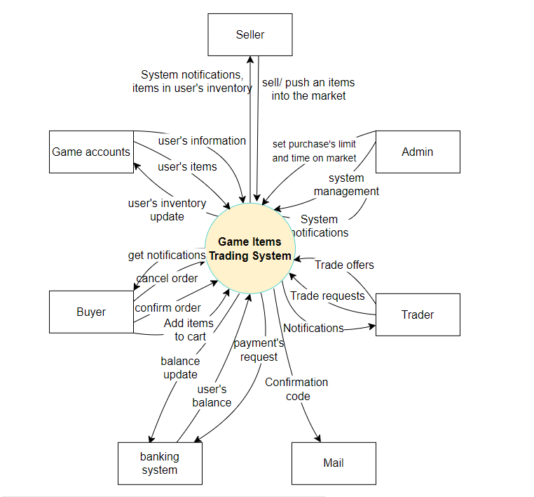

## System functions

### Screen Flow

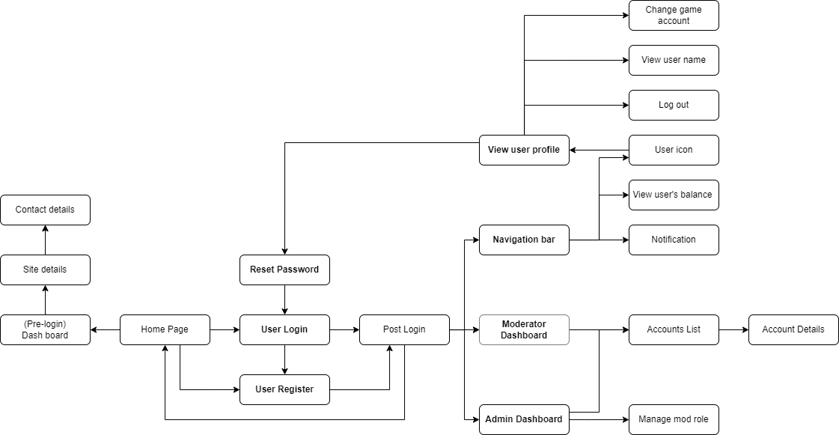

### Screen Details

### 

|  |  |  |  |
| --- | --- | --- | --- |
| **#** | **Feature** | **Screen** | **Description** |
| **1** | Login | User login | User enter their username, password. |
| **2** | Login | Forget password | User can reset their password |
| **3** | Register | Create site account | User fill in their username, password. |
| **4** | Register | Link game account | User fill in their game account,game account password. If account is already link to an account, user must enter another one. |
| **5** | Trade | Trade list | Show list of offers : offer includes a list of items the offerer requests in exchange for their items. Users can accept the offer if they have the offerer's requested items. Estimated price for both the offerer’s items and their requested items will be printed on the offer. |
| **6** | Trade | Add trade | Users can add an offer to the trade market, selecting items they are offering up for items they want and showing the estimated price for both the offerer’s items and their requested item. |
| **7** | Sell | Item inventory | User can view game account items. |
| **8** | Sell | Sell Request | Set price and time it will stay on the market. A price history for the selected items will also be presented. |
| **9** | Buy | Buy market | Show list of sell offers, items of high rarity are shown first with lower ones after. |
| **10** | Buy | Buy Request | Add items to cart. |
| **11** | Buy | Cart | Show cart total amount, user can complete transaction with funds from their account. |
| **12** | Auction | Action market | Show list of active actioned offers, items of high rarity are shown first with lower ones after. |
| **13** | Auction | Send bid | Users can send a bid for actioned items, and can only send bids higher than the current highest bidder. User with the highest bid after the auction is over gets the items. |
| **14** | Auction | Auction request | Set items up for auction, users can set floor price, minimum amount for counter bid, and time limit of auction. |
| **15** | Help center | Send question | User can send question and communicate with admins. |
| **16** | Help center | Respond question | Admins can accept question and communicate with users. |
| **17** | Sorting | Search by sort | Users can search for items by price, rarity, type, (trade / buy / auction) market. |
| **18** | Search | Search by name | Users can search for items by name. |
| **19** | Items detail | View detail | Show price, rarity, type, time added, seller of viewed items. |
| **20** | View History | History | View history of sell, buy, trade, auction. Can view active or completed transactions. Can cancel active transactions. |
| **21** | View user profile | User Profile | Users can reset password, link bank account, change game account (denied if game account is already linked on site ), add funds from bank account to website wallet.  Sign out button. |

### 

### User Authorization

|  |  |  |  |
| --- | --- | --- | --- |
| **Screen** | **Guest** | **User** | **Admin** |
| User login | x | x | x |
| Forget password |  | x | x |
| Create site account | x | x | x |
| Link game account | x | x | x |
| Trade list | x | x | x |
| Add trade |  | x | x |
| Item inventory |  | x | x |
| Sell Request |  | x | x |
| Buy market | x | x | x |
| Buy Request |  | x | x |
| Cart |  | x | x |
| Action market | x | x | x |
| Send bid |  | x | x |
| Auction request | x | x | x |
| Send question |  | x |  |
| Respond question |  |  | x |
| Search by sort | x | x | x |
| View detail | x | x | x |

### Non-Screen Function

|  |  |  |  |
| --- | --- | --- | --- |
| **#** | **Feature** | **System Function** | **Description** |
| 1 | Support multiple currency | Switch item’s price to Vietnam dong, dollars, Euro or ruble | Convert price number from dollars by default to other currency |

# Functional Requirements

## Navigation bar



### Buy, sell, trade, auction page navigation

* + 1. Function trigger: Upon clicking on buttons
    2. Function description:
       1. Lead user to corresponding sites

### Show user’s balance and avatar

* + 1. Function trigger: Upon visiting the website
    2. Function description:
       1. If you are logged in. the web site should display your balance and avatar. If not, a log in button will be displayed instead
       2. When you click on the avatar, it will drop down a list of options containing: My Profile, Log Out. The first option will take you to the user’s profile page while the second option will log out your account

## Sorting feature

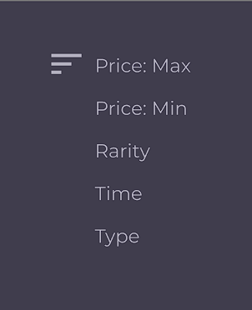

### Sort by price

* Function trigger: upon entering either starting price or final price, choosing sort by price in the sorting drop down list
* Function description:
  + Sort out items whose price is in the inputted range
  + Sort items ascending/descending by price

### Sort by rarity

* Function trigger: user choosing sort by rarity in the sorting drop down list
* Function description:
  + Sort out items whose rarity is in the selected range
  + Sort items ascending/descending by rarity
  + Show a filter for user to choose rarity

### Sort by time

* + 1. Function trigger: user choosing sort by time in the sorting drop down list
    2. Function description:
       1. Sort out items whose time bought is in the inputted range
       2. Sort items ascending/descending by time
       3. Show a date box to select specific time

### Sort by type

* Function trigger: user choosing sort by item type in the sorting drop down list
* Function description:
  + Sort out items whose type is in the selected item type
  + Sort items ascending/descending by
  + Show a filter for user to choose item type

## Log In feature

### Login

* Function trigger: User clicks on sign in button in Home Page
* Function description:
  + 1. Show boxes for user to sign in their game accounts
    2. Show a button Log in to log in the website
    3. If the username and the password is matched in the game accounts database, the user’s screen will navigate to the home page
    4. If any one of the above is unsatisfied, the screen remain in log in section, and a pop-up say that the username or the password is incorrect

- Screen layout:

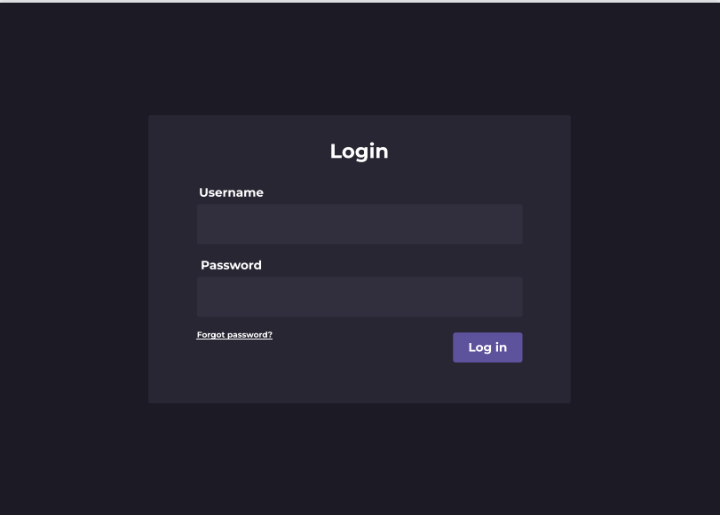

### Forgot password

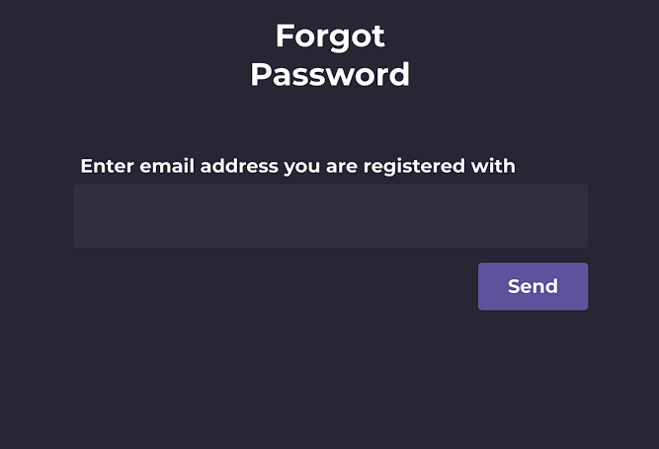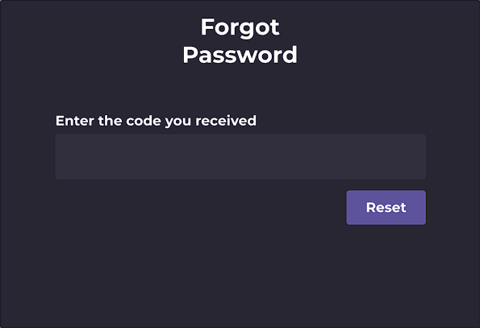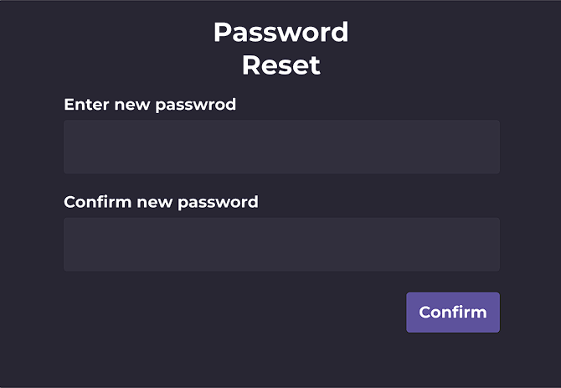

* Function trigger: User clicks on Forgot password button in Login Page
* Function description:
  + 1. Show a line Forget password to reset, system will send a code to the email address linked with the account’s user name
    2. System display a form for user to input the code and a button to resend the link
    3. After the form is submitted, system will compare the code inputted and the code sent
    4. If user is validated, redirect user to a form to reset user password, then redirect user to buy page
    5. If the code invalidated, resent user the code and prompt user for input again

## Sign up feature

### Sign up with game accounts

* Function trigger: User clicks on sign up new account
* Function description:

i. Show boxes for user to input game account’s name and password

ii. If the game account is validated, the screen will move to the second second form for user to fill out informations for their account on the website

iii. If the information is unsatisfied, the user will be asked to input again

* Screen display:

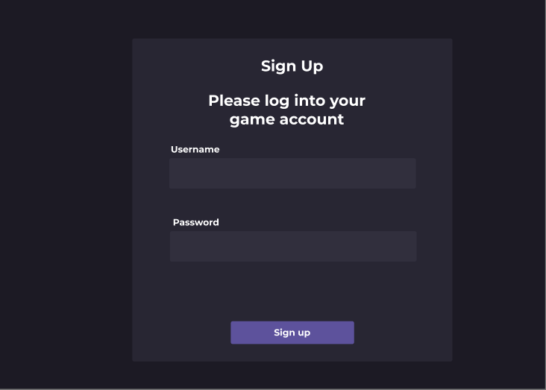

### Create account on website

* Function trigger: After user’s game account is validated
* Function description:

i. User inputs their username and real name

ii. User input password and re-input it to minimize chance of mistake

iii. After filling in form, user will be taken to the buy page and receive a welcome notification

* Screen display:

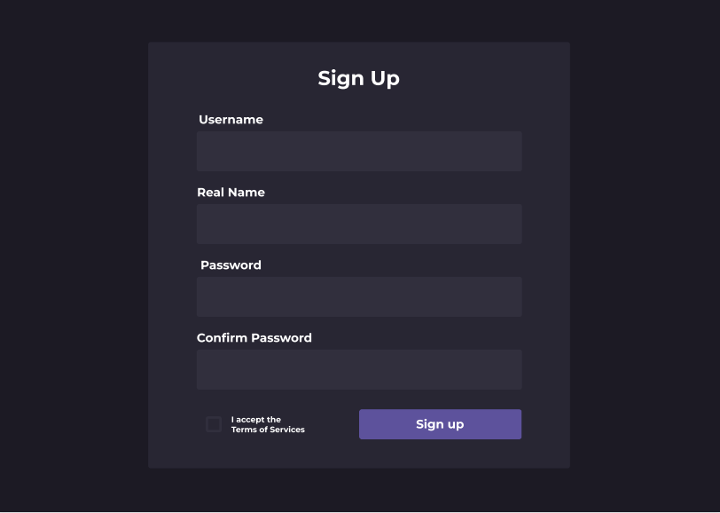

## Sell Feature

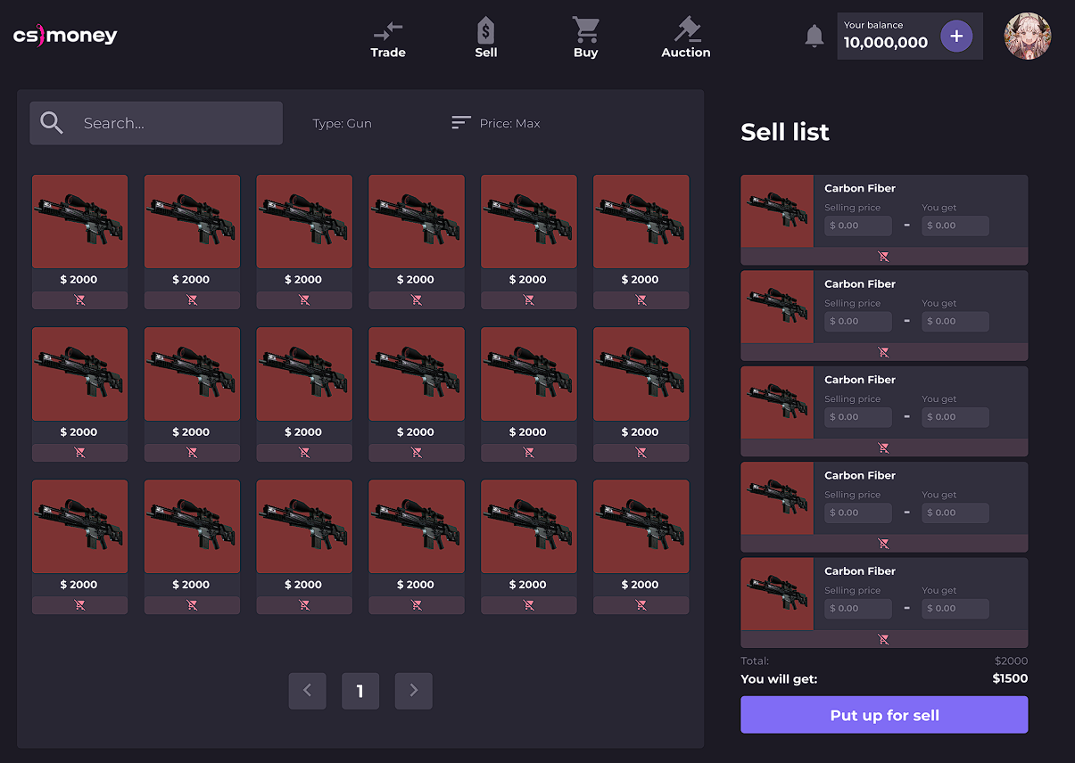

### View user’s items

* Function trigger: User clicks on Sell button on Home Page
* Function description:

1. Show a search box to find item you want to sell
2. Show a item filter based on price
3. Show a list of item you want to sell on sell list
4. Show user’s
5. Show a sell button

### b. Choose item to sell and offer details

* Function trigger: User choose on item want to sell
* Function description:

1. If the item is allowed to sell, the user can choose that item to sell, choose the price, how long it will last on stock and view item’s description
2. If the item is banned, the user cannot choose the item
3. If the user want to sell, the user will click on sell button

* Screen display:

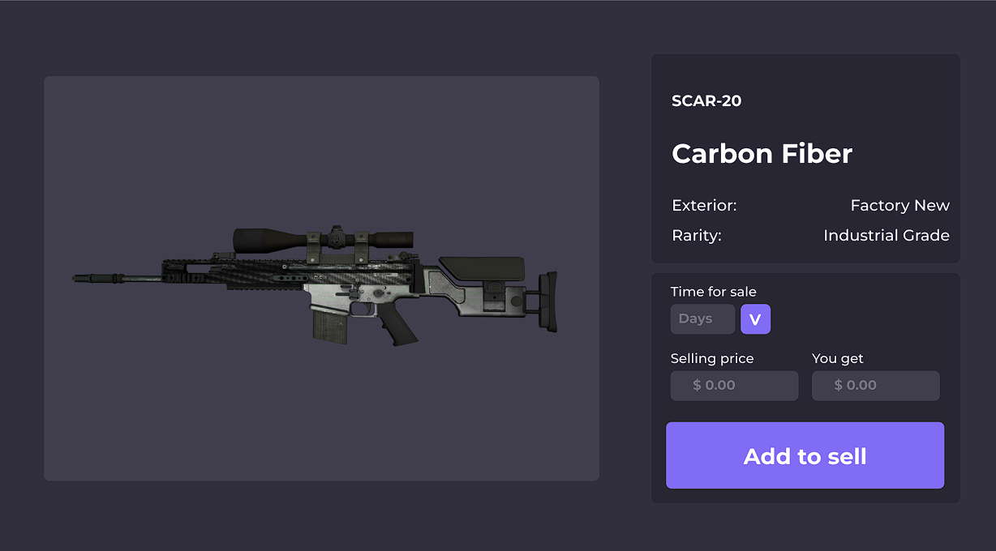

## Buy Feature

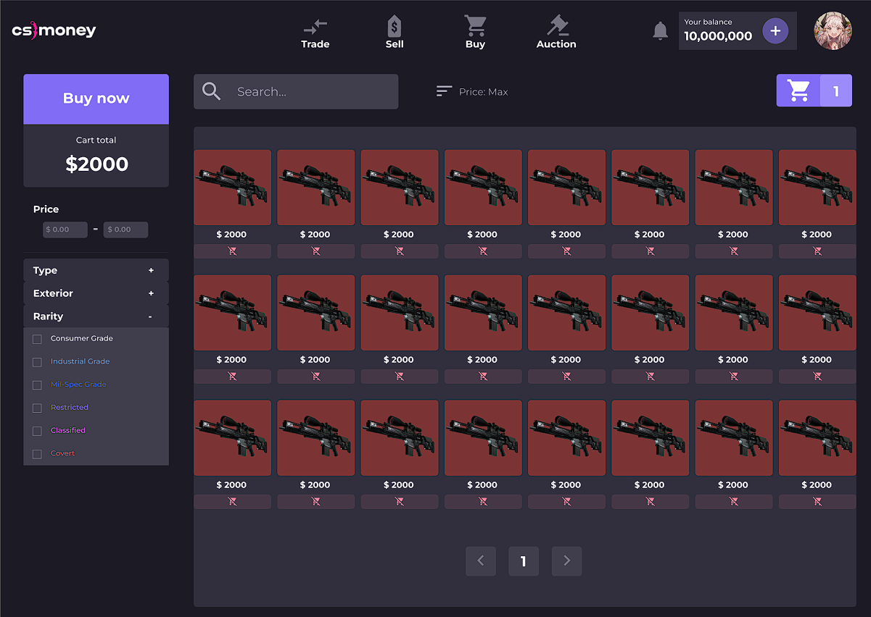

### Add to cart

* Function trigger: User choose Buy section
* Function description

i. Show items in the market

ii. The user chooses the item want to buy

iii. The user can view the item has chosen in cart

### Delete from cart

* Function trigger: User choose on cart
* Function description:

i. The user choose the item want to remove in cart and choose remove

* Screen display:

### Get notifications

* Function trigger: When a user has made a successful buy
* Function description:

i. If user confirms the buy and then it has been executed, a notification will pop-up and say: “You have successfully buy (item name) at (time)”

* Screen display:

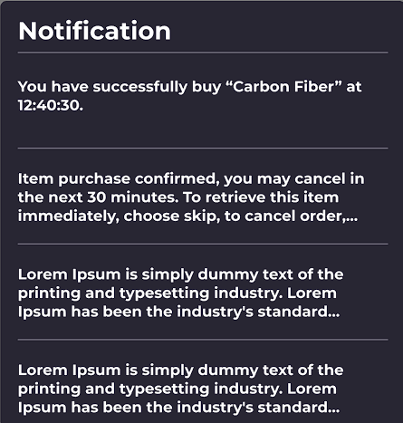

## Trade feature

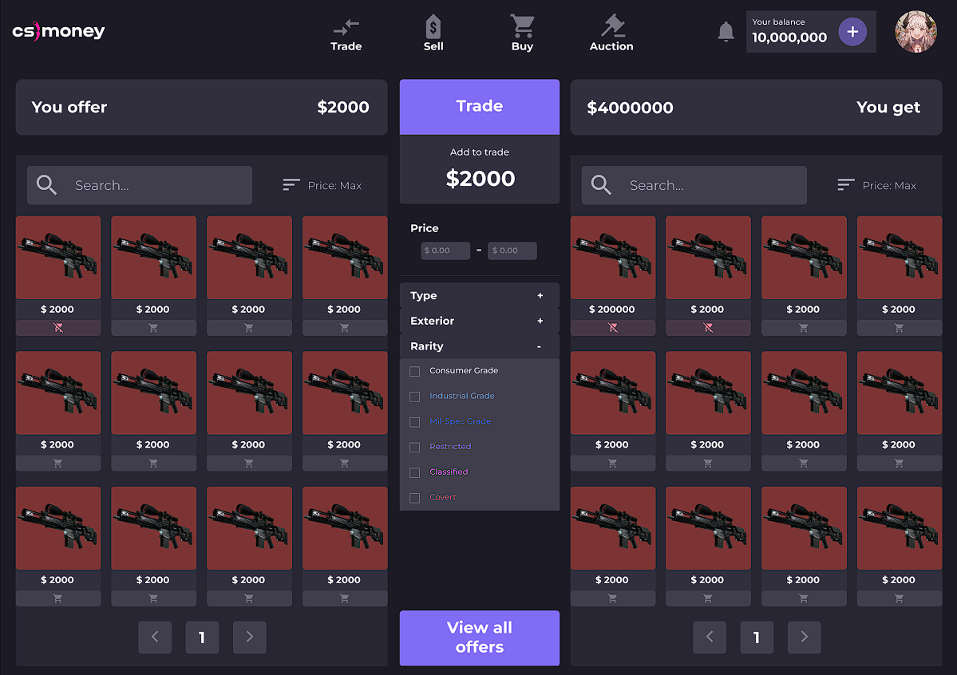

### View other trade options

* Function trigger: When a user clicks on a trade not created by that user
* Function description:

i. User can view other trade information (item, date)

ii. User can decide to trade with others or not by clicking the Trade button

### Add trade offers/offer’s details

* Function trigger: When user chooses Add trade
* Function description:

i. User can choose the item want to trade

ii. User can set the time that the item is available on stock

### Cancel Trade offers

* Function trigger: When user chooses Cancel trade on the trade created by that user
* Function description:

i. User clicks on cancel trade button

ii. A pop-up appears to confirm the action. If the user chooses yes, the trade will be removed, and if the user chooses no, the trade will remain.

### Get notifications

* Function trigger: When a user click on Trade button and make a successful trade
* Function description:

i. If user confirms the trade and then it has been executed, a notification will pop-up and say: “You have successfully trade (item name) with (item name) at (time)”

## Help Center

### Answer question

* Function trigger: When authorized individual click on questions asked by users
* Function description:

i. Show a box chat with the user

ii. This person will type out the answer and send to the user ask that question

### Add question

* Function trigger: When user clicks on Support button on the Home Page
* Function description:

i. Show a box chat with the support

ii. User can type the question and send the message to the support

## User Profile

### View profile

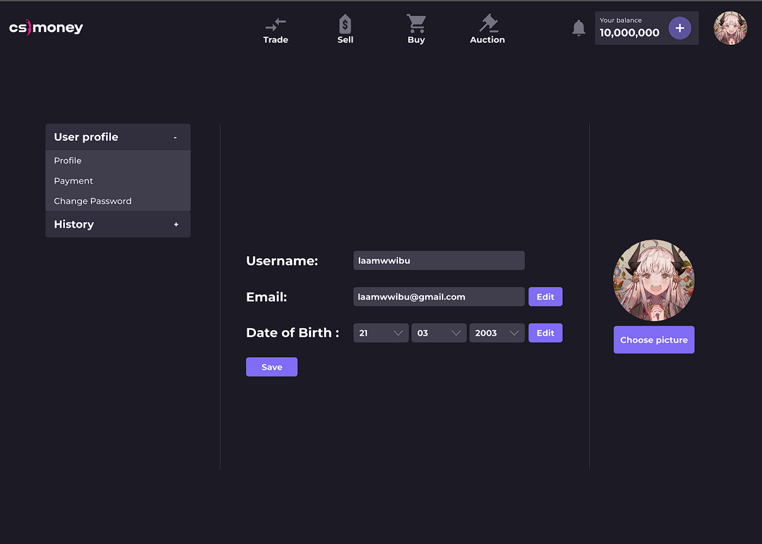

* Function trigger: When user clicks on profile on the Home Page
* Function description:

i. Show user’s information

ii. User can change information in profile

### Reset password



* Function trigger: When user clicks on Reset password on profile
* Function description:

i. Show boxes to enter new password after reset

ii. Asked user re-input the new password to confirm

iii. If the re-input password is correct and the user clicks Reset, the screen will move to the Home Page

iv. If the re-input is incorrect, the user will be asked to input a again

### Log out

* Function trigger: When user clicks on Log out on profile
* Function description:

i. Show the Log-in page